**SPRING CORE_MAVEN**

* **Exercise 1: Configuring a Basic Spring Application**

**Pom.xml**

<project xmlns="http://maven.apache.org/POM/4.0.0"

xmlns:xsi="http://www.w3.org/2001/XMLSchema-instance"

xsi:schemaLocation="http://maven.apache.org/POM/4.0.0

http://maven.apache.org/xsd/maven-4.0.0.xsd">

<modelVersion>4.0.0</modelVersion>

<groupId>com.library</groupId>

<artifactId>LibraryManagement</artifactId>

<version>1.0</version>

<dependencies>

<dependency>

<groupId>org.springframework</groupId>

<artifactId>spring-context</artifactId>

<version>5.3.34</version>

</dependency>

</dependencies>

</project>

**Com.library.main.MainApp**

package com.library.main;

import org.springframework.context.ApplicationContext;

import org.springframework.context.support.ClassPathXmlApplicationContext;

import com.library.model.Book;

import com.library.service.BookService;

import java.util.List;

public class MainApp {

public static void main(String[] args) {

ApplicationContext context = new ClassPathXmlApplicationContext("applicationContext.xml");

BookService bookService = (BookService) context.getBean("bookService");

bookService.addBook(new Book(1, "Effective Java", "Joshua Bloch"));

bookService.addBook(new Book(2, "Clean Code", "Robert C. Martin"));

Book book = bookService.getBookById(1);

System.out.println("Fetched Book: " + book);

List<Book> allBooks = bookService.getAllBooks();

System.out.println("All Books:");

for (Book b : allBooks) {

System.out.println(b);

}

bookService.deleteBook(2);

System.out.println("Book with ID 2 deleted");

allBooks = bookService.getAllBooks();

System.out.println("Books after deletion:");

for (Book b : allBooks) {

System.out.println(b);

}

}

}

**Com.library.model.Book**

package com.library.model;

public class Book {

private int id;

private String title;

private String author;

public Book() {}

public Book(int id, String title, String author) {

this.id = id;

this.title = title;

this.author = author;

}

public int getId() {

return id;

}

public void setId(int id) {

this.id = id;

}

public String getTitle() {

return title;

}

public void setTitle(String title) {

this.title = title;

}

public String getAuthor() {

return author;

}

public void setAuthor(String author) {

this.author = author;

}

@Override

public String toString() {

return "Book [id=" + id + ", title=" + title + ", author=" + author + "]";

}

}

**Com.library.service.BookService**

package com.library.service;

import java.util.List;

import com.library.model.Book;

import com.library.repository.BookRepository;

public class BookService {

private BookRepository bookRepository;

public void setBookRepository(BookRepository bookRepository) {

this.bookRepository = bookRepository;

}

public void addBook(Book book) {

bookRepository.save(book);

}

public Book getBookById(int id) {

return bookRepository.findById(id);

}

public List<Book> getAllBooks() {

return bookRepository.findAll();

}

public void deleteBook(int id) {

bookRepository.deleteById(id);

}

}

**Com.library.repository.BookRepository**

package com.library.repository;

import java.util.ArrayList;

import java.util.HashMap;

import java.util.List;

import java.util.Map;

import com.library.model.Book;

public class BookRepository {

private Map<Integer, Book> books = new HashMap<>();

public void save(Book book) {

books.put(book.getId(), book);

}

public Book findById(int id) {

return books.get(id);

}

public List<Book> findAll() {

return new ArrayList<>(books.values());

}

public void deleteById(int id) {

books.remove(id);

}

}

**applicationContext.xml**

<?xml version="1.0" encoding="UTF-8"?>

<beans xmlns="http://www.springframework.org/schema/beans"

xmlns:xsi="http://www.w3.org/2001/XMLSchema-instance"

xsi:schemaLocation="

http://www.springframework.org/schema/beans

https://www.springframework.org/schema/beans/spring-beans.xsd">

<bean id="bookRepository" class="com.library.repository.BookRepository"/>

<bean id="bookService" class="com.library.service.BookService">

<property name="bookRepository" ref="bookRepository"/>

</bean>

</beans>

**OUTPUT**

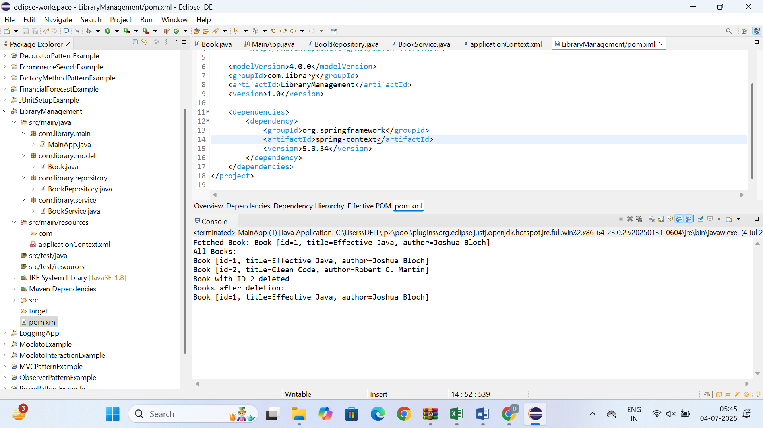

* **Exercise 2: Implementing Dependency Injection**

**Pom.xml**

<project xmlns="http://maven.apache.org/POM/4.0.0"

xmlns:xsi="http://www.w3.org/2001/XMLSchema-instance"

xsi:schemaLocation="http://maven.apache.org/POM/4.0.0

<http://maven.apache.org/xsd/maven-4.0.0.xsd>">

<modelVersion>4.0.0</modelVersion>

<groupId>com.library</groupId>

<artifactId>LibraryManagement</artifactId>

<version>1.0-SNAPSHOT</version>

<dependencies>

<dependency>

<groupId>org.springframework</groupId>

<artifactId>spring-context</artifactId>

<version>5.3.34</version>

</dependency>

</dependencies>

</project>

**LibraryManagementApplication .java**

package com.library.main;

import org.springframework.context.ApplicationContext;

import org.springframework.context.support.ClassPathXmlApplicationContext;

import com.library.service.BookService;

public class LibraryManagementApplication {

public static void main(String[] args) {

ApplicationContext context = new ClassPathXmlApplicationContext("applicationContext.xml");

BookService bookService = (BookService) context.getBean("bookService");

System.out.println("===== Library Book List =====");

bookService.displayBooks();

System.out.println("===== End of List =====");

}

}

**Book.java**

package com.library.model;

public class Book {

private String title;

private String author;

public Book() {

}

public Book(String title, String author) {

this.title = title;

this.author = author;

}

public String getTitle() {

return title;

}

public void setTitle(String title) {

this.title = title;

}

public String getAuthor() {

return author;

}

public void setAuthor(String author) {

this.author = author;

}

public String toString() {

return "Book [Title=" + title + ", Author=" + author + "]";

}

}  
  
**BookService.java**

package com.library.service;

import com.library.repository.BookRepository;

import com.library.model.Book;

import java.util.List;

public class BookService {

private BookRepository bookRepository;

public void setBookRepository(BookRepository bookRepository) {

this.bookRepository = bookRepository;

}

public void displayBooks() {

List<Book> books = bookRepository.getAllBooks();

for (Book book : books) {

System.out.println(book);

}

}

}

**BookRepository.java**

package com.library.repository;

import com.library.model.Book;

import java.util.Arrays;

import java.util.List;

public class BookRepository {

public List<Book> getAllBooks() {

return Arrays.asList(

new Book("The Alchemist", "Paulo Coelho"),

new Book("1984", "George Orwell"),

new Book("Clean Code", "Robert C. Martin")

);

}

}

**applicationContext.xml**

<?xml version="1.0" encoding="UTF-8"?>

<beans xmlns="http://www.springframework.org/schema/beans"

xmlns:xsi="http://www.w3.org/2001/XMLSchema-instance"

xsi:schemaLocation="http://www.springframework.org/schema/beans

http://www.springframework.org/schema/beans/spring-beans.xsd">

<bean id="bookRepository" class="com.library.repository.BookRepository" />

<bean id="bookService" class="com.library.service.BookService">

<property name="bookRepository" ref="bookRepository" />

</bean>

</beans>

**OUTPUT**

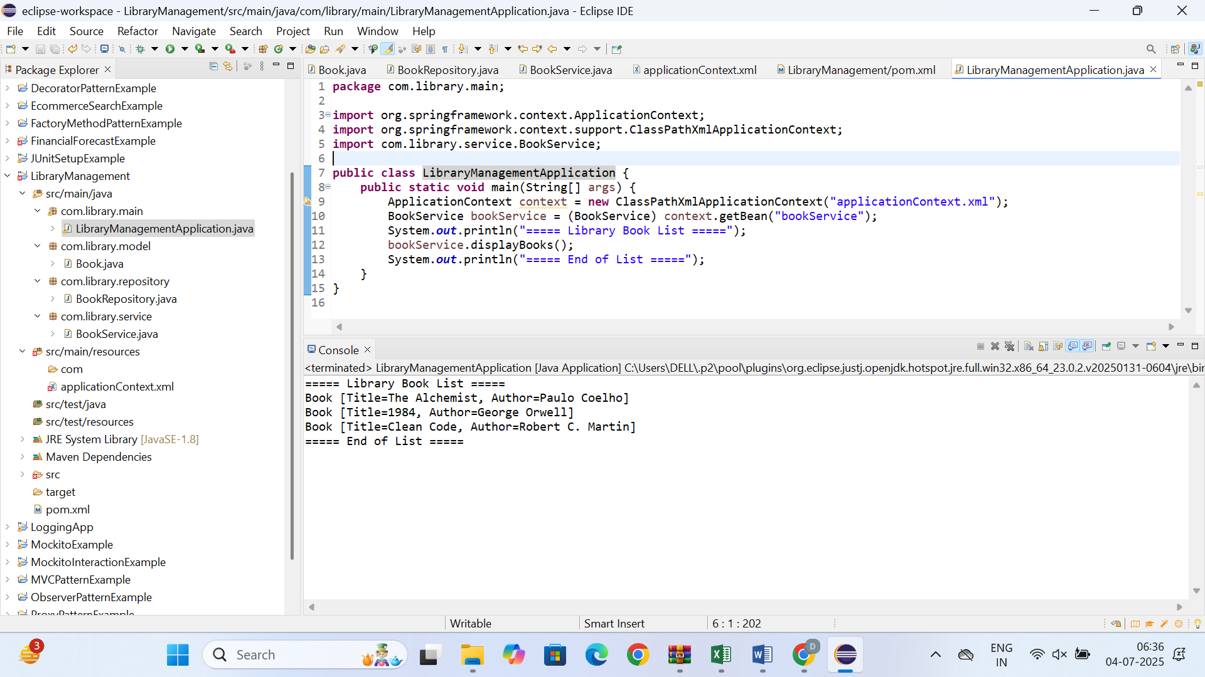

* **Exercise 3: Implementing Logging with Spring AOP**

**pom.xml**

<project xmlns="http://maven.apache.org/POM/4.0.0"

xmlns:xsi="http://www.w3.org/2001/XMLSchema-instance"

xsi:schemaLocation="http://maven.apache.org/POM/4.0.0

http://maven.apache.org/xsd/maven-4.0.0.xsd">

<modelVersion>4.0.0</modelVersion>

<groupId>com.library</groupId>

<artifactId>LibraryManagement</artifactId>

<version>1.0-SNAPSHOT</version>

<dependencies>

<dependency>

<groupId>org.springframework</groupId>

<artifactId>spring-context</artifactId>

<version>5.3.33</version>

</dependency>

<dependency>

<groupId>org.springframework</groupId>

<artifactId>spring-aop</artifactId>

<version>5.3.33</version>

</dependency>

<dependency>

<groupId>org.aspectj</groupId>

<artifactId>aspectjweaver</artifactId>

<version>1.9.21</version>

</dependency>

</dependencies>

</project>

**LoggingAspect.java**

package com.library.aspect;

import org.aspectj.lang.ProceedingJoinPoint;

import org.aspectj.lang.annotation.Around;

import org.aspectj.lang.annotation.Aspect;

@Aspect

public class LoggingAspect {

@Around("execution(* com.library.service.*.*(..))")

public Object logExecutionTime(ProceedingJoinPoint joinPoint) throws Throwable {

long start = System.currentTimeMillis();

Object result = joinPoint.proceed();

long duration = System.currentTimeMillis() - start;

System.out.println("Execution time of " + joinPoint.getSignature().getName() + ": " + duration + " ms");

return result;

}

}

**Book.java**

package com.library.model;

public class Book {

private String title;

private String author;

public Book() {}

public Book(String title, String author) {

this.title = title;

this.author = author;

}

public String getTitle() {

return title;

}

public String getAuthor() {

return author;

}

}

**BookRepository.java**

package com.library.repository;

import com.library.model.Book;

import java.util.Arrays;

import java.util.List;

public class BookRepository {

public List<Book> getAllBooks() {

return Arrays.asList(

new Book("The Alchemist", "Paulo Coelho"),

new Book("1984", "George Orwell"),

new Book("Clean Code", "Robert C. Martin")

);

}

}

**BookService.java**

package com.library.service;

import com.library.repository.BookRepository;

import com.library.model.Book;

import java.util.List;

public class BookService {

private BookRepository bookRepository;

public void setBookRepository(BookRepository bookRepository) {

this.bookRepository = bookRepository;

}

public void displayBooks() {

List<Book> books = bookRepository.getAllBooks();

for (Book book : books) {

System.out.println(book);

}

}

}

**applicationContext.xml**

<?xml version="1.0" encoding="UTF-8"?>

<beans xmlns="http://www.springframework.org/schema/beans"

xmlns:xsi="http://www.w3.org/2001/XMLSchema-instance"

xmlns:aop="http://www.springframework.org/schema/aop"

xsi:schemaLocation="

http://www.springframework.org/schema/beans

http://www.springframework.org/schema/beans/spring-beans.xsd

http://www.springframework.org/schema/aop

http://www.springframework.org/schema/aop/spring-aop.xsd">

<bean id="bookRepository" class="com.library.repository.BookRepository"/>

<bean id="bookService" class="com.library.service.BookService">

<property name="bookRepository" ref="bookRepository"/>

</bean>

<bean id="loggingAspect" class="com.library.aspect.LoggingAspect"/>

<aop:config>

<aop:aspect ref="loggingAspect">

<aop:around method="logExecutionTime"

pointcut="execution(* com.library.service.BookService.displayBooks(..))"/>

</aop:aspect>

</aop:config>

</beans>

**OUTPUT**

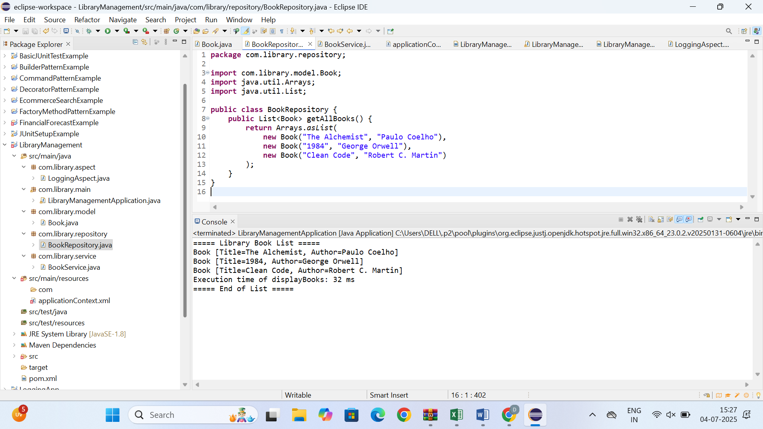

* **Exercise 4: Creating and Configuring a Maven Project**

**Pom.xml**

<project xmlns="http://maven.apache.org/POM/4.0.0"

xmlns:xsi="http://www.w3.org/2001/XMLSchema-instance"

xsi:schemaLocation="http://maven.apache.org/POM/4.0.0

http://maven.apache.org/xsd/maven-4.0.0.xsd">

<modelVersion>4.0.0</modelVersion>

<groupId>com.example</groupId>

<artifactId>LibraryManagement</artifactId>

<version>1.0-SNAPSHOT</version>

<packaging>jar</packaging>

<name>LibraryManagement</name>

<description>Library Management System using Spring</description>

<properties>

<java.version>1.8</java.version>

<spring.version>5.3.36</spring.version>

</properties>

<dependencies>

<dependency>

<groupId>org.springframework</groupId>

<artifactId>spring-context</artifactId>

<version>${spring.version}</version>

</dependency>

<dependency>

<groupId>org.springframework</groupId>

<artifactId>spring-aop</artifactId>

<version>${spring.version}</version>

</dependency>

<dependency>

<groupId>org.springframework</groupId>

<artifactId>spring-webmvc</artifactId>

<version>${spring.version}</version>

</dependency>

<dependency>

<groupId>javax.servlet</groupId>

<artifactId>javax.servlet-api</artifactId>

<version>4.0.1</version>

<scope>provided</scope>

</dependency>

</dependencies>

<build>

<plugins>

<plugin>

<groupId>org.apache.maven.plugins</groupId>

<artifactId>maven-compiler-plugin</artifactId>

<version>3.10.1</version>

<configuration>

<source>${java.version}</source>

<target>${java.version}</target>

</configuration>

</plugin>

</plugins>

</build>

</project>

**applicationContext.xml**

<?xml version="1.0" encoding="UTF-8"?>

<beans xmlns="http://www.springframework.org/schema/beans"

xmlns:xsi="http://www.w3.org/2001/XMLSchema-instance"

xsi:schemaLocation="http://www.springframework.org/schema/beans

http://www.springframework.org/schema/beans/spring-beans.xsd">

<!-- Define a simple bean -->

<bean id="libraryService" class="com.example.service.LibraryService" />

</beans>

**Main.java**

package com.example;

import org.springframework.context.ApplicationContext;

import org.springframework.context.support.ClassPathXmlApplicationContext;

import com.example.service.LibraryService;

public class Main {

public static void main(String[] args) {

ApplicationContext context = new ClassPathXmlApplicationContext("applicationContext.xml");

LibraryService service = context.getBean("libraryService", LibraryService.class);

service.displayMessage();

}

}

**LibraryService.java**

package com.example.service;

public class LibraryService {

public void displayMessage() {

System.out.println("✅ Spring context loaded successfully.");

System.out.println("📚 Welcome to the Library Management System!");

}

}

**OUTPUT**

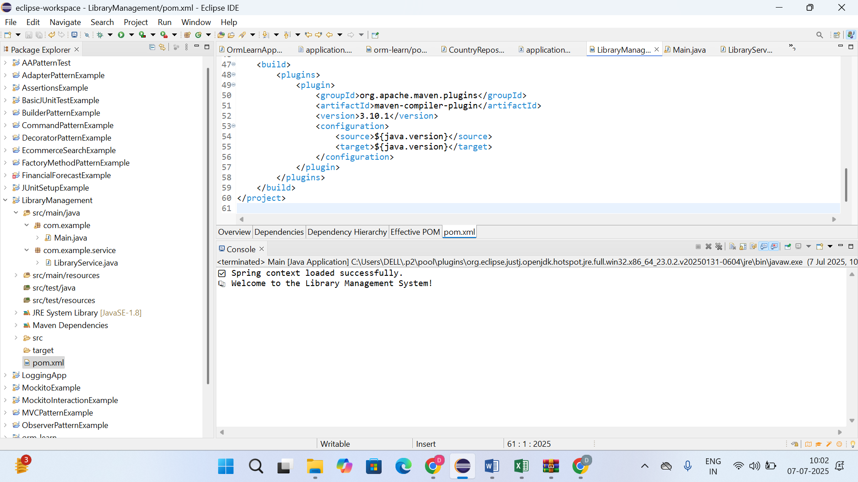

* **Exercise 5: Configuring the Spring IoC Container**

**pom.xml**

<project xmlns="http://maven.apache.org/POM/4.0.0"

xmlns:xsi="http://www.w3.org/2001/XMLSchema-instance"

xsi:schemaLocation="http://maven.apache.org/POM/4.0.0

http://maven.apache.org/xsd/maven-4.0.0.xsd">

<modelVersion>4.0.0</modelVersion>

<groupId>com.library</groupId>

<artifactId>LibraryManagement</artifactId>

<version>1.0-SNAPSHOT</version>

<dependencies>

<dependency>

<groupId>org.springframework</groupId>

<artifactId>spring-context</artifactId>

<version>5.3.30</version>

</dependency>

<dependency>

<groupId>org.springframework</groupId>

<artifactId>spring-aop</artifactId>

<version>5.3.30</version>

</dependency>

<dependency>

<groupId>org.springframework</groupId>

<artifactId>spring-webmvc</artifactId>

<version>5.3.30</version>

</dependency>

<dependency>

<groupId>org.aspectj</groupId>

<artifactId>aspectjweaver</artifactId>

<version>1.9.20.1</version>

</dependency>

</dependencies>

<build>

<plugins>

<plugin>

<groupId>org.apache.maven.plugins</groupId>

<artifactId>maven-compiler-plugin</artifactId>

<version>3.8.1</version>

<configuration>

<source>1.8</source>

<target>1.8</target>

</configuration>

</plugin>

</plugins>

</build>

</project>

**Book.java**

package com.library.model;

public class Book {

private String title;

private String author;

public Book(String title, String author) {

this.title = title;

this.author = author;

}

public String toString() {

return "Book [Title=" + title + ", Author=" + author + "]";

}

}

**BookService.java**

package com.library.service;

import java.util.List;

import com.library.model.Book;

import com.library.repository.BookRepository;

public class BookService {

private BookRepository bookRepository;

public void setBookRepository(BookRepository bookRepository) {

this.bookRepository = bookRepository;

}

public void displayBooks() {

List<Book> books = bookRepository.findAllBooks();

System.out.println("===== Library Book List =====");

for (Book book : books) {

System.out.println(book);

}

System.out.println("===== End of List =====");

}

}

**BookRepository.java**

package com.library.repository;

import java.util.Arrays;

import java.util.List;

import com.library.model.Book;

public class BookRepository {

public List<Book> findAllBooks() {

return Arrays.asList(

new Book("The Alchemist", "Paulo Coelho"),

new Book("1984", "George Orwell"),

new Book("Clean Code", "Robert C. Martin")

);

}

}

**applicationContext.xml**

<?xml version="1.0" encoding="UTF-8"?>

<beans xmlns="http://www.springframework.org/schema/beans"

xmlns:xsi="http://www.w3.org/2001/XMLSchema-instance"

xsi:schemaLocation="

http://www.springframework.org/schema/beans

http://www.springframework.org/schema/beans/spring-beans.xsd">

<bean id="bookRepository" class="com.library.repository.BookRepository" />

<bean id="bookService" class="com.library.service.BookService">

<property name="bookRepository" ref="bookRepository" />

</bean>

</beans>

**LibraryManagementApplication.java**

package com.library.main;

import org.springframework.context.ApplicationContext;

import org.springframework.context.support.ClassPathXmlApplicationContext;

import com.library.service.BookService;

public class LibraryManagementApplication {

public static void main(String[] args) {

ApplicationContext context = new ClassPathXmlApplicationContext("applicationContext.xml");

BookService bookService = (BookService) context.getBean("bookService");

bookService.displayBooks();

}

}

**OUTPUT**

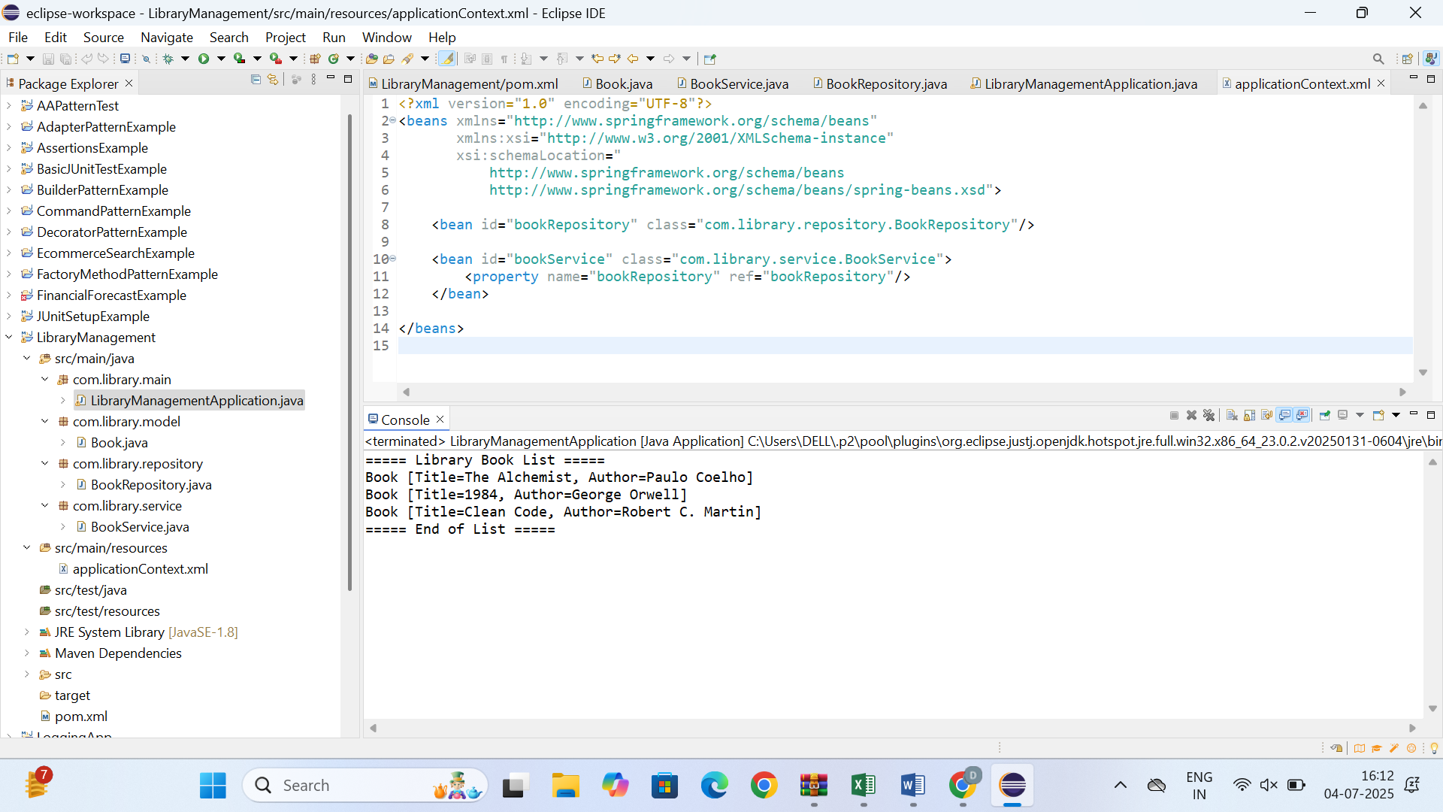

* **Exercise 7: Implementing Constructor and Setter Injection**

**pom.xml**

<project xmlns="http://maven.apache.org/POM/4.0.0"

xmlns:xsi="http://www.w3.org/2001/XMLSchema-instance"

xsi:schemaLocation="http://maven.apache.org/POM/4.0.0

http://maven.apache.org/xsd/maven-4.0.0.xsd">

<modelVersion>4.0.0</modelVersion>

<groupId>com.library</groupId>

<artifactId>LibraryManagement</artifactId>

<version>1.0-SNAPSHOT</version>

<dependencies>

<dependency>

<groupId>org.springframework</groupId>

<artifactId>spring-context</artifactId>

<version>5.3.30</version>

</dependency>

<dependency>

<groupId>org.springframework</groupId>

<artifactId>spring-aop</artifactId>

<version>5.3.30</version>

</dependency>

<dependency>

<groupId>org.springframework</groupId>

<artifactId>spring-webmvc</artifactId>

<version>5.3.30</version>

</dependency>

<dependency>

<groupId>org.aspectj</groupId>

<artifactId>aspectjweaver</artifactId>

<version>1.9.20.1</version>

</dependency>

</dependencies>

<build>

<plugins>

<plugin>

<groupId>org.apache.maven.plugins</groupId>

<artifactId>maven-compiler-plugin</artifactId>

<version>3.8.1</version>

<configuration>

<source>1.8</source>

<target>1.8</target>

</configuration>

</plugin>

</plugins>

</build>

</project>

**Book.java**

package com.library.model;

public class Book {

private String title;

private String author;

public Book() {}

public Book(String title, String author) {

this.title = title;

this.author = author;

}

public String toString() {

return "Book [Title=" + title + ", Author=" + author + "]";

}

}

**BookRepository.java**  
package com.library.repository;

import java.util.ArrayList;

import java.util.List;

import com.library.model.Book;

public class BookRepository {

public List<Book> getBooks() {

List<Book> books = new ArrayList<>();

books.add(new Book("The Alchemist", "Paulo Coelho"));

books.add(new Book("1984", "George Orwell"));

books.add(new Book("Clean Code", "Robert C. Martin"));

return books;

}

}

**BookService.java**

package com.library.service;

import com.library.repository.BookRepository;

public class BookService {

private BookRepository bookRepository;

public BookService() {

System.out.println("BookService: Constructor called");

}

public void setBookRepository(BookRepository bookRepository) {

this.bookRepository = bookRepository;

System.out.println("BookService: Setter injection called");

}

public void displayBooks() {

System.out.println("===== Library Book List =====");

bookRepository.getBooks().forEach(System.out::println);

System.out.println("===== End of List =====");

}

}

**LibraryManagementApplication.java**

package com.library.main;

import com.library.service.BookService;

import org.springframework.context.ApplicationContext;

import org.springframework.context.support.ClassPathXmlApplicationContext;

public class LibraryManagementApplication {

public static void main(String[] args) {

ApplicationContext context = new ClassPathXmlApplicationContext("applicationContext.xml");

BookService bookService = (BookService) context.getBean("bookService");

bookService.displayBooks();

}

}

**applicationContext.xml**

<?xml version="1.0" encoding="UTF-8"?>

<beans xmlns="http://www.springframework.org/schema/beans"

xmlns:xsi="http://www.w3.org/2001/XMLSchema-instance"

xsi:schemaLocation="http://www.springframework.org/schema/beans

http://www.springframework.org/schema/beans/spring-beans.xsd">

<bean id="bookRepository" class="com.library.repository.BookRepository"/>

<bean id="bookService" class="com.library.service.BookService">

<property name="bookRepository" ref="bookRepository"/>

</bean>

</beans>

**OUTPUT**

